{{FREE ROBUX}} Free Robux Generator 2021#ROBLOX {No Human Verification}

how to get robux for free 2021,free robux,how to get free robux easy 2021,free robux generator,how to get free robux without verifying,free robux codes,roblox free robux hack,how to get robux for free 2021 no human verification.

Finally, we are proud to present the new tool Free Robux Generator in which you can get free robux online for Roblox and with no survey and no human verification required. Other than getting money Roblox, players also have a fantastic opportunity. This hack tool to match roblox servers algorithm, use it before they fix it again. It is the biggest gaming stage created by clients and has a month to month client base of 100 million.

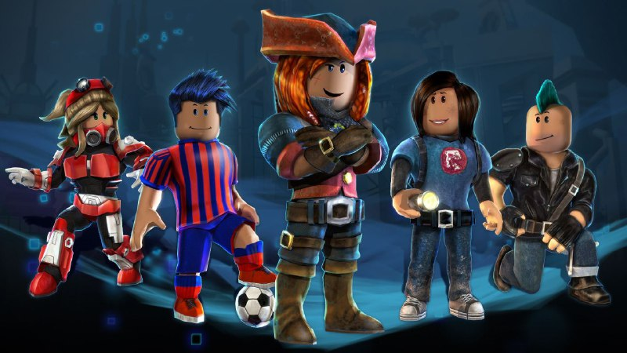

## Free Robux Generator 2021 ##

CLICK HERE ►► <https://t.co/W02aBYYnqn>

CLICK HERE ►► <https://t.co/W02aBYYnqn>

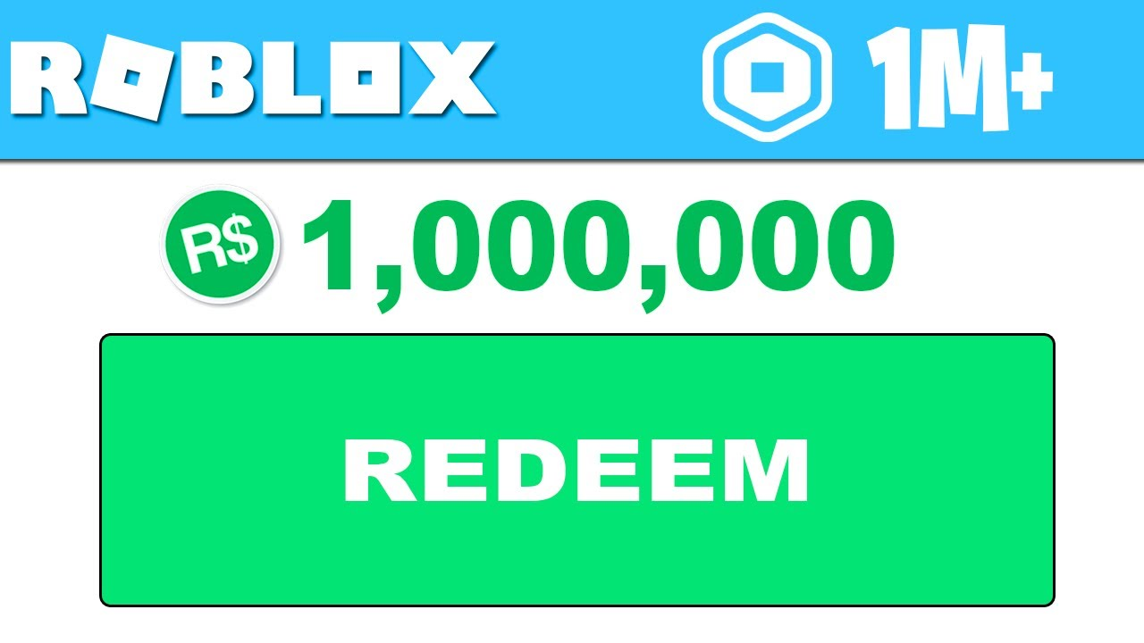

This hack tool to match roblox servers algorithm, use it before they fix it again. Other than getting money Roblox, players also have a fantastic opportunity. Being a Robux and Builders club is a superb milestone for any Roblox Robux gamer who has a deep understanding of the sport.

He proven fact that there are so many free roblox generators which might be simply accessible. By doing this, you may always keep yourself informed about the most recent promo codes and hacks to make Robux. Send a'Connect' request to all of such classes and if you're lucky enough, then your connect' request will be approved and you will grow to be a part of a couple of these classes.

Programmers of different games give away some voucher codes to their games. Further, to ensure that the hacks available on any site are absolutely risk-free and genuine, consider using them to gauge their efficacy. If you're the person searching for answers regarding how to get free robux, we've obtained some coupon codes you could use to get this game.

[Robux Generator - Robux Generators] No Human Verification Robux Generator, Robux Generators, Free Robux, FREE V-BUCKS GENERATOR, Free Robux Generator, FREE Robux Roblox, FREE Robux HACK, Roblox Generator, Roblox Robux, Roblox Robux HACK, Roblox HACK Robux, Roblox Robux GENERATOR, Roblox FREE Robux GENERATOR, VBuck Generator, Robux Generator, V-BUCKS FREE, V-BUCKS GENERATOR, Robux

how to get robux for free 2021,

free robux,

how to get free robux easy 2021,

free robux generator,

how to get free robux without verifying,

free robux codes,

roblox free robux hack,

how to get robux for free 2021 no human verification,

Join thousands of ROBLOX fans in earning ROBUX, Events and FREE Giveaways without entering your password! Login to RBX PAGE! Please insert your username to start earning robux! ... So, you want FREE Robux? With RBX Page, you can earn hundreds of ROBUX in just a few minutes! EARN ROBUX NOW! Create Account. Complete Tasks. Withdraw Robux.

Roblox Robux Hack | How to get Free Robux in Roblox [2021]

Impress your friends with huge amount of Free Robux with this new Roblox Hack. If you are looking for method to get free Robux in Roblox then I´m sure that this new Robux Hack is exactly what you are looking for . You need to know that it will be working very well. After using our Generator you will be surprised how you can dominate the game easily taking advantage of premium in game features !

Simply use this new Roblox Hack in order to gain all Robux you would like.

Do not worry you will be protected while doing this and no one will see you are cheating. This is due to fact that this Roblox Hack will be protected thanks to a great Anti-Ban feature. This feature will hide all of your private and personal data. You will only need to focus on the gameplay instead of grinding for long periods of time, and you will like it! Hack is working great also if you are using your Android as well as IOS mobile phones, Its supports all platforms. Have a great game experience with this Online Robux Hack.

Roblox Hack Screenshot

roblox robux hack

General Features :

-Very simple to use by anyone and it has a very user friendly interface.

-Anti-ban shield to secure your in-game account[You will never get banned using our hacks]

-Gain access to free Robux and take advantage in Roblox game.

-Updated every time with the game version.

-24/7 Online Access .

-If you are on phone you do not have to root your Android or jailbreak your IOS device.